Step 1 – Go into Dreamweaver by clicking on Start, All Programs, Adobe Web Premium CS4 and Dreamweaver.
Click on OK
Step 2 - Start a new HTML document from the middle column on the screen.
Make sure the Design Button is clicked
Step 3 - Insert a table by clicking on Insert and select Table
Make it 3 by 3 and click on OK
Step 4 - Click on the bottom right hand corner and drag the box so it is 4 times the size
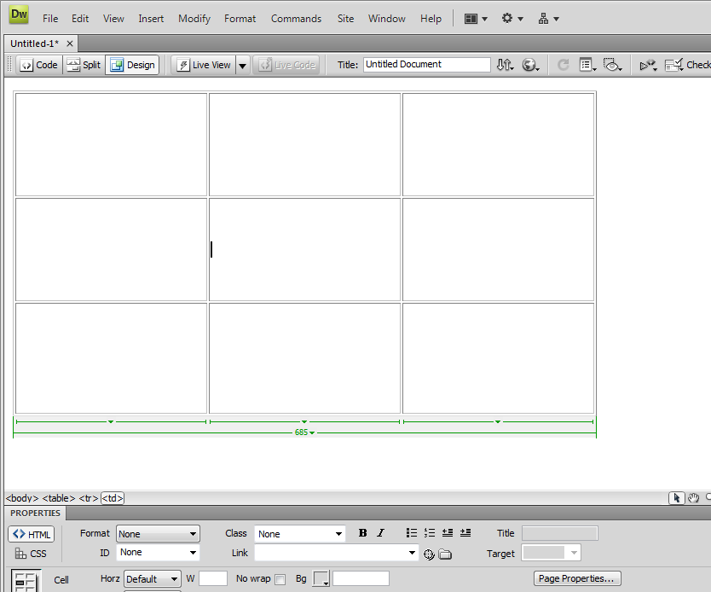
Should now look like this. Click the mouse into the middle cell.
Step 5 - On the right hand side click on the drop down Insert menu where Common is and select Forms
Click on Form, a red box should now be in the table.
Step 6 - Type 1 to 5 in the box
Make 5 questions like the ones shown or others of your choice about recycling.
Step 7 - Click on List Manu on the right hand side.
Type in Please Choose in the box that appears.
Step 7 - Then double click on the small box that has appeared
At the bottom of the screen click on List Values
Add in your first type and then click on the +
When you have them all done like above, click on OK
Step 8 - Go under the next question and choose Checkbox
In the Label write Yes
Click to the right hand side of yes and then do the Checkbox again for No.
It should now look like this.
Step 9 - The next question should be a Radio group, click on Radio Button on the Right hand side.
Do not add in anything to the next box and click on OK
Step 10 - When you have 5, add in words between them to explain them.
For the next one just copy and paste the previous Yes/No one.
Step 11 - For the last question we want the user to be able to write in their answers. Choose text field from the Right hand side.
Write some explanation in the Label field
Should now look like this after pressing OK.
Double click on the box and select Multiline from the bottom of the Screen.
Step 12 - Next create a Button from the right hand menu by scrolling down.
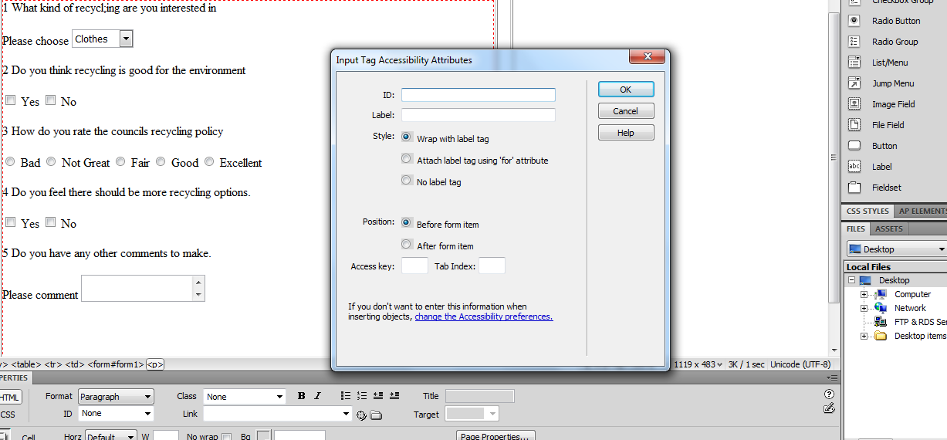
Do not write anything on it, click on OK
Move to the right hand side of it and do it all again, you should now have two submit buttons.
Step 13 - Double click on one of the Submit Buttons and click on Reset on the bottom of the screen.
Finally click once on the Submit button and then click on the form1form link underneath it once.
All the text should go black like above.
Type in an email address in the Action box like above and press enter.
Then save the webpage and press F12. This will then preview the page. Test that it works, test the drop down menu, test the reset and submit button.
Well done.

